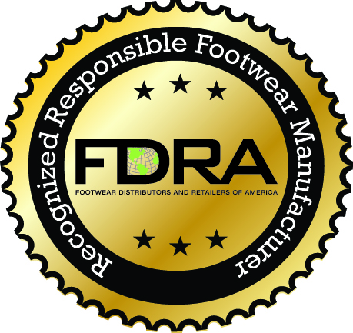
FDRA’s Code of Conduct
Footwear Company Participation Form

Name of Company:

Social Compliance Director/Contact Name:
Title:
Email:
Phone:

Number of Factories in Your Factory Base:

Do you agree to:

- Use FDRA’s code of conduct as your baseline social compliance code for your factories (you can have higher standards)
- Send your factory base a copy of FDRA’s Code of Conduct and ask them to comply

Yes No

Will you recognize, and nominate, factories that FDRA designates as highly compliant factories?

Yes No

